8-2-2026
lLaila Zareth Romano Guerrero
DDYA-7
Ejercicios de las diapositivas
Semana 2


- Ordenar las siguientes funciones de menor a mayor orden:
- $\log{\log{n}}$
- $\log{n}$
- $\ln{n}$
- ${\left(\log{n}\right)}^{2}$
- $\sqrt{n}$
- $n$
- $n\log{n}$
- $n^{1+ε} 0<ε<1$
- $n^{2}$
- $n^{2}+\log{n}$
- $n-n^{3}+{7n}^{5}$
- $2^{n-1}$
- $2^{n}$
- $e^{n}$
- $n^{3}$
- $n!$
- Para las siguientes funciones, determinar el resultado como una función de n y representar el peor caso de ejecución con notación Big Oh:

Código | COST | TIME
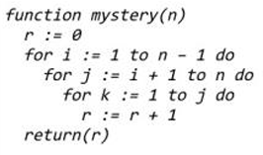 | $$C_{1}$$ | $$1$$
 | $$C_{2}$$ | $$n$$
 | $$C_{3}$$ | $$n\left[\sum_{j=i+1}^{n}{t_{j}}\right]$$
 | $$C_{4}$$
 | $$C_{5}$$ | $$n\left[\sum_{j=i+1}^{n}{t_{j}}-1\right]\left[(\sum_{k=1}^{j}{t_{k}})\right]$$
 | $$C_{6}$$ | $$n\left[\sum_{j=i+1}^{n}{t_{j}}-1\right]\left[(\sum_{k=1}^{j}{t_{k}}-1)\right]$$

Peor caso:
$$T(n) = O(n^{3})$$

Código | Costo | Tiempo
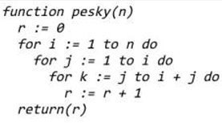 | $$C_{1}$$ | $$1$$
 | $$C_{2}$$ | $$n$$
 | $$C_{3}$$ | $$(n-1)\left[\sum_{j=1}^{i}{t_{j}}\right]$$
 | $$C_{4}$$ | $$(n-1)\left[\sum_{j=1}^{i}{t_{j}-1}\right]\left[\sum_{k=j}^{i+j}{t_{k}-1}\right]$$
 | $$C_{5}$$ | $$(n-1)\left[\sum_{j=1}^{i}{t_{j}-1}\right]\left[\sum_{k=j}^{i+j}{t_{k}-1}\right]$$
 | $$C_{6}$$ | $$1$$

Peor caso:
$$T(n)=O(n^{3})$$

Código | Costo |  | Tiempo
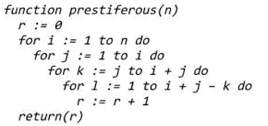 |  | $$C_{1}$$ | $$1$$
 |  | $$C_{2}$$ | $$n$$
 |  | $$C_{3}$$ | $$(n-1) \left[\sum_{j=i}^{i}{t_{j}}\right]$$
 |  | $$C_{4}$$ | $$\left(n-1\right)\left[\sum_{j=i}^{i}{t_{j}}-1\right]\left[\sum_{k=j}^{i+j}{t_{k}}\right]$$
 |  | $$C_{5}$$ | $$\left(n-1\right)\left[\sum_{j=i}^{i}{t_{j}}-1\right]\left[\sum_{k=j}^{i+j}{t_{k}-1}\right]\left[\sum_{l = 1}^{i+j-k}{t_{l}}\right]$$
 |  | $$C_{6}$$ | $$\left(n-1\right)\left[\sum_{j=i}^{i}{t_{j}}-1\right]\left[\sum_{k=j}^{i+j}{t_{k}-1}\right]\left[\sum_{l = 1}^{i+j-k}{t_{l}-1}\right]$$
 |  | $$C_{7}$$ | $$1$$

Peor caso:
$$T(n) = O(n^{4})$$

- Implementar el algoritmo de insertion sort para ordenar de forma descendente en vez de ascendente.
